Introduction to Exponential Functions
1. Simplify the following
a) ${\left(w^{2}v\right)}^{3}$ b) $(5c^{-4})(-4m^{2}c^{8})$

c) $\frac{21x^{3}y}{3xy^{4}}$ d) ${\left(12x^{2}y^{-2}\right)}^{2}$

e) ${\left(\frac{5a^{8}}{10a^{6}}\right)}^{-3}$

2. Identify each sequence as arithmetic or geometric. Write the recursive form and explicit form for each.
a) 1600, 400, 100, 25, … b) 14, 21, 28, 35, …

3. Does the table of values represent a linear function or an exponential function? Explain.

Exponential Functions are of the form $f(x)=a{\left(b\right)}^{x}$
a = INITIAL VALUE
b = BASE (also called the growth or decay factor)
x represents the INPUT
f(x) or y represents the OUTPUT
the y-intercept occurs at (0, a) and the base b represents the common ratio as seen with geometric sequences
if the base is greater than 1, the function is exponential growth
if the base is between 0 and 1, the function is exponential decay

What do you know?
- $f\left(x\right)=2{\left(3\right)}^{x}$
- $g\left(x\right)=1523{\left(1.05\right)}^{x}$
- $h\left(x\right)=256{\left(0.85\right)}^{x}$
- $k\left(x\right)=32{\left(0.956\right)}^{x}$

Exponential Functions
Determine whether each function is exponential growth or exponential decay.
- ____________________ 2. ____________________ 3. ____________________
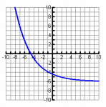
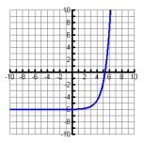
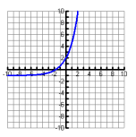

- ____________________ 5. ____________________ 6. ____________________

$y=3{(0.75)}^{x}$ $y=2.4{(1.07)}^{x}$ $y=\frac{5}{8}{(3)}^{x}$

- ____________________ 8. ____________________ 9. ____________________

$y=8{\left(\frac{6}{7}\right)}^{x}$ $y=\frac{4}{3}{\left(\frac{1}{9}\right)}^{x}$ $y=3.14{(2.84)}^{5x}$

10. Suppose an investment of $10,000 doubles in value every 13 years. How much is the investment worth after 52 years?

11. A population of 100 insects triples in size every month. Write an equation and find how many insects there are after 5 months.

12. A tennis match begins with 64 players. Each round, half of the players are eliminated. Write an equation and find out when there will be a winner (i.e., one player left).

13. You drop a ball from a height of 12 feet. Each path has 3/5 the height of the previous path. Write an equation and find the height at the top of the fourth path.

