GUIDED NOTES – Lesson 7-1
Graphing Logarithmic Functions Name: ______________________ Period: ___

OBJECTIVE: I can identify the types of exponential functions, as well as evaluate and graph them.
GRAPHING: Logarithmic functions are really just the inverse function of exponentials.
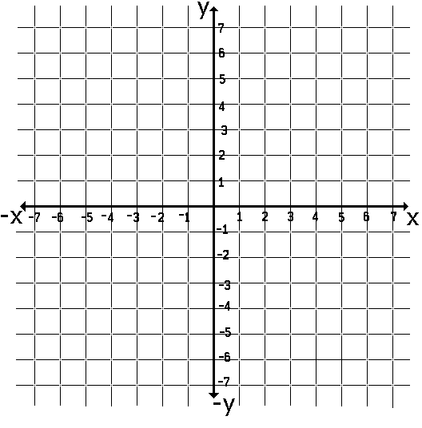
EXPONENTIAL FUNCTION INVERSE FUNCTION
$y=2^{x}$ $x=2^{y}$
x | y
 | -1
 | 0
 | 1
 | 2
 | 3

x | y
-1
0
1
2
3

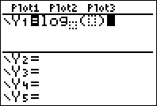

LOGARITHMIC FUNCTION (write the inverse as a log like lesson 6-5)

$2^{y}=x$ $log$

For the parent function, $y=\log_{b}x$, the graph contains the ordered pairs (1, 0) and (b, 1). It has an asymptote at x = 0.

Domain: Range: x-intercept: y-intercept: Asymptote:

TRANSFORMATIONS: $f\left(x\right)={(a)log}_{b}(x-h)+k$

h tells us about horizontal movement.

If h is positive… If h is negative…

a tells us about stretching, reflecting, and compressing.

If a is negative… If a > 1… If 0 < a < 1…

k tells us about vertical movement.

If k is positive… If k is negative…
So to graph logarithmic functions with transformations…
- Plot the parent function ordered pairs and asymptote. (1, 0) and (b, 1)
- Move each ordered pair and the asymptote h units and k units

$y=\log_{2}(x+3)$ $y=\log_{2}\left(x-1\right)+3$

Domain: Range: Domain: Range:

x-intercept: y-intercept: x-intercept: y-intercept:

Asymptote: Asymptote:

$y=-\log_{2}x$ $y=-\log_{2}\left(x+2\right)-3$

Domain: Range: Domain: Range:

x-intercept: y-intercept: x-intercept: y-intercept:

Asymptote: Asymptote:
COMMON LOG-BASE 10

When we use a common log with base 10, it is not necessary to indicate the base.

$log15$ really means (to the calculator) $log$ which is _____

Use the log button on the calculator to take the base 10 log of any number.

Evaluate: Log 4 Log -2 Log 7

How do we evaluate logarithms that are not common? Not all of the logs we need to take will be base 10….

Change of base formula: so try that with $\log_{20}135$

Evaluate using change of base: $\log_{2}8$ $\log_{3}4$ $\log_{\frac{1}{2}}9$

But wait!!! If you have a newer calculator you can do the following….

