Review Problems
Do your work on a seperate sheet of paper
If you need more problems contact me and I will find you some
Also work through the ready, set, goes in the workbook

Piecewise Functions
http://www.shelovesmath.com/algebra/advanced-algebra/piecewise-functions/
This website is a great tool for piecewise functions.

Write a piecewise function for each graph. And state the domain and range of the following graph.
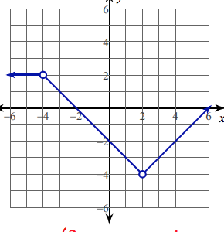
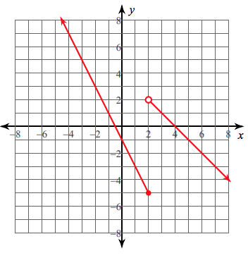
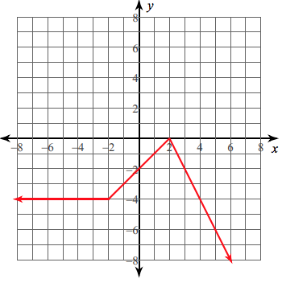

Solve and Graph Absolute Value Equations and Inequalities
$\left|3x-7\right|=2$ $2\left|x-1\right|-4≥2$ $3\left|4x-1\right|≤9$

$\left|x^{2}+1\right|=5$ $\left|3x+2\right|=10$ $\left|x+3\right|<-6$

https://www.khanacademy.org/math/algebra-home/alg-absolute-value
This is a great tool also for absolute value equations, functions and inequalities

Evaluate the functions
Given $f(x)=2x-1$, $g(x)=3x$, and $h(x)=x^{2}+1$compute:

$g(f(0))$ $(h∘g)(x)$ $f(g(h(2)))$

Given $f(x)=9-x$, $g(x)=x^{2}+x$, and $h(x)=x-2$. Compute the following:

$(g∘f)(3)$ $f(g(x))$ $h(f(-6))$

$f(h(x))$ $(h∘g)(11)$ $g(h(x))$

Inverses
Given $f(x)=2(x-3){}^{2}-7$
- Graph $f(x)$
- State the range and domain of $f(x)$
- Find $f{}^{-1}(x)$
- Graph $f{}^{-1}(x)$
- State the range and domain of $f{}^{-1}(x)$

Given $f(x)=-\frac{1}{2}(x-2){}^{2}+6$
- Graph $f(x)$
- State the range and domain of $f(x)$
- Find $f{}^{-1}(x)$
- Graph $f{}^{-1}(x)$
- State the range and domain of $f{}^{-1}(x)$
- Evaluate $f(6)$
- Evaluate $f{}^{-1}(-2)$

Find the inverse of the given functions and state the domain and range of the function and inverse.

Given $f(x)=\sqrt{x-1}+3$ Given $f(x)=5x-7$

Given $f(x)=\sqrt{x-7}$ Given $f(x)=3(x-7){}^{2}+5$

Given $f(x)=9x-10$

Direct and Inverse Variation

The pressure P of a compressed gas is inversely proportional to the volume V. If there is a pressure of 25 pounds per square inch when the volume of gas is 400 cubic inches, find the pressure when the gas is compressed to 200 cubic inches.

Hooke’s law states that the distance d that a spring is stretched by a hanging object varies directly as the mass m of the object. If the distance is 20 cm when the mass is 3 kg, what is the distance when the mass is 8 kg?

The time T required to do a job varies inversely as the number of people P working. It takes 5 hours for 7 volunteers to pick up rubbish from 1 mile of roadway. How long would it take 12 volunteers to complete the job?

