MVP Math 3 Unit 4 Quiz #1 Form A Name ______________________________

1. Paula opened Pizza Palace and only sold 6 pizzas on the first day. She was worried about her business until
she realized that the number of number of pizzas she sold was increasing by 3 each day. Let d(x) represent
the daily number of pizzas sold and let t(x) represent the total number of pizzas sold since she opened.
a) Paula was so busy selling pizzas she didn’t have time to finish her inventory chart. Help her out by
Day x | Daily sales d(x) | Total sales t(x)
1 | 6 | 6
2 | 9 | 15
3 | 12
4
5
completing the tables:

b) Write a recursive formula for d(x) (Paula’s daily sales).

c) Write an explicit formula for d(x) (Paula’s daily sales).

d) Write a recursive formula for t(x) (Paula’s total sales).

e) Write an explicit formula for t(x) (Paula’s total sales).

f) If Pizza Palace’s success continues, how many pizzas would Paula sell on day 100? (show work)

g) Circle the correct answer: The d(x) function is ? .
A. Quadratic B. Linear C. Exponential D. Cubic

h) Circle the correct answer: The t(x) function is ? .
A. Quadratic B. Linear C. Exponential D. Cubic
2. Solve the following quadratic equations by factoring. Show your work.
a) f(x) = x² + 5x – 6 b) g(x) = x² + 3x + 2

3. Determine if (2x + 1) is a factor of 2x³ – 5x² + 8x – 3 by using long division. Show your work.

4. How many roots will the polynomial f(x) = 3x⁵ + 2x³ – 4x² + 6 have? Circle the correct answer.

A. 3 B. 4 C. 5 D. 6 E. not possible to determine

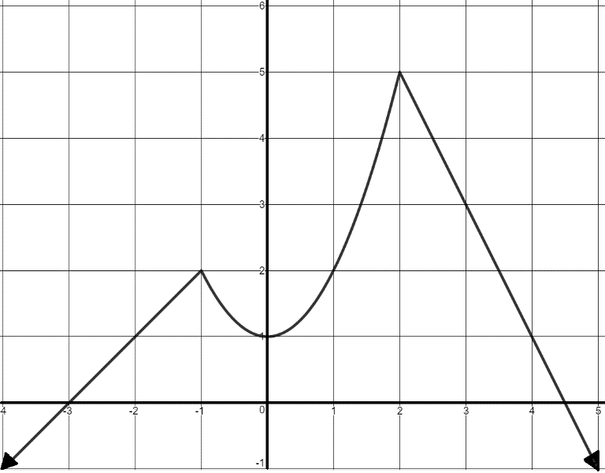
5. Answer the following questions from the graph shown.

a. Domain: ____________________________

b. Range : _____________________________

c. Roots: _____________________________

d. y-intercept: __________________________

e. increasing: ___________________________

f. decreasing: ___________________________
g. write the function in piecewise form :

